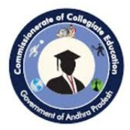
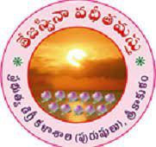
Government Degree College for Men, Srikakulam
Event Organized Report
2022-2023
Name of Department/ Cell | Cultural Club
Name of Event Organized | Independence Day Celebrations
Title of the Event | Independence Day 2023 Celebrations
Date of Event Organized | August 15, 2023
Name of the coordinator of the Event | Dr. S. Dilleswara Rao
No. of Participant(Student + Staff) | 118
Name of the Guest with designation | Dr. P. Surekha, Principal
Objective of the Event | To celebrate the 77th Independence Day of India and to honor the sacrifices made by our ancestors for the country's freedom. To instill a sense of patriotism and pride in the students and staff.
Description of the event | Independence Day 2023 was celebrated with great enthusiasm and patriotic fervor at Government Degree College for Men, Srikakulam. The event commenced with the arrival of the chief guest, Principal Dr. P. Surekha, who was received by the NCC Cadets with a Guard of Honor.  The celebration began with the flag hoisting ceremony by the chief guest, Dr. P. Surekha. As the tricolor was unfurled, the national anthem was sung, filling the air with patriotic spirit. Following the flag hoisting, Dr. P. Surekha delivered an inspiring and motivational speech that resonated deeply with the students and staff. She emphasized the importance of our motherland, its rich heritage, and the value of freedom. Her words instilled a sense of pride and responsibility in the audience.  Vice Principal Sri. M.V. Satyanarayana then addressed the gathering, elaborating on the sacrifices made by our forefathers to achieve independence. He recounted historical events and the relentless struggle of freedom fighters, reminding everyone of the hard-fought battles that led to India's freedom.  IQAC Coordinator Dr. R. Haritha motivated the students by delivering a powerful speech on the real meaning of patriotism. She encouraged the students to embody the values of unity, integrity, and dedication to the nation, urging them to contribute positively to society and uphold the ideals of our great leaders.  The event continued with a series of cultural programs, showcasing the talent and creativity of the students. Patriotic songs were sung by both students and staff, creating an atmosphere of national pride and unity. Following the musical performances, a prize distribution ceremony was held to recognize and reward students for their achievements in various academic and extracurricular activities.  The cultural segment featured dance performances that depicted the spirit of India's freedom struggle and celebrated the nation's diverse culture. Students performed traditional and contemporary dances, highlighting the cultural heritage and national pride.  The celebration concluded with a vote of thanks, expressing gratitude to all the participants, organizers, and attendees for making the event a success. The entire college community left the venue with a renewed sense of patriotism and a deeper appreciation for the freedom and independence we enjoy today.
Outcome of the Event | The Independence Day celebration at Government Degree College for Men, Srikakulam, successfully fostered a spirit of patriotism and unity among the students and staff. The motivational speeches, cultural programs, and flag hoisting ceremony reinforced the importance of national pride and the sacrifices made by our ancestors. The event also provided a platform for students to showcase their talents and express their love for the country through various performances. Overall, the celebration strengthened the bond within the college community and highlighted the significance of independence and freedom.
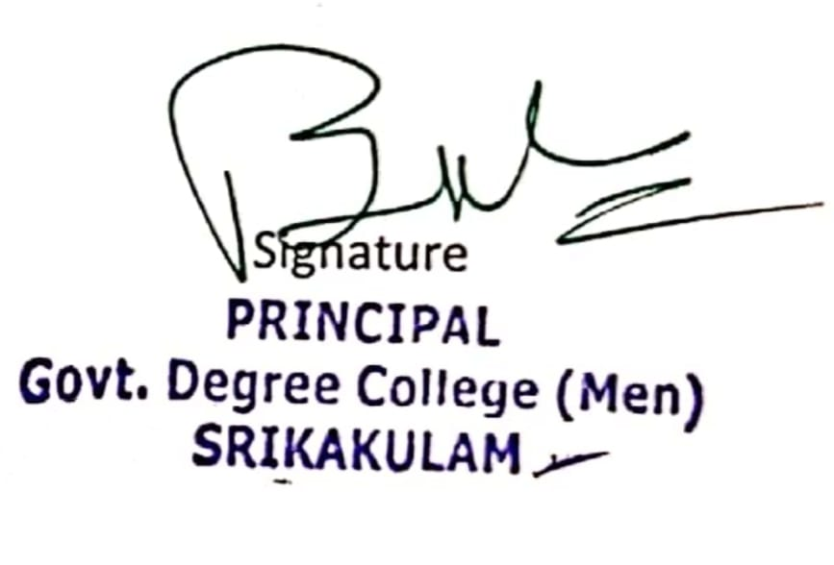

Government Degree College for Men, Srikakulam

Event Photo Gallery
